Functions and Function Notation

Key Points:

- A relation is a set of ordered pairs. A function is a specific type of relation in which each domain value, or input, leads to exactly one range value, or output.
Example: The coffee shop menu, shown below, consists of items and their prices.
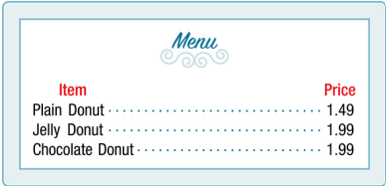
- Is price a function of the item?
- Is the item a function of the price?
Solution:
- Let’s begin by considering the input as items on the menu. The output values are then the prices. Each item on the menu has only one price, so the price is a function of the item.
- Two items on the menu have the same price. If we consider the prices to be the input values and the items to be the output, then the same input value could have more than one output associated with it (see the image below). Therefore, the item is not a function of the price.
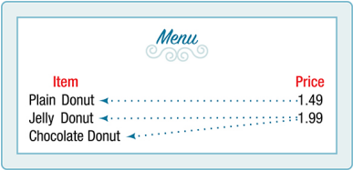

- Function notation is a shorthand method for relating the input to the output in the form $y=f(x)$.
Example: Use function notation to represent a function whose input is the name of a month and output is the number of days in that month. Assume that the domain does not include leap years.
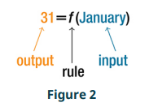
Solution: The number of days in a month is a function of the name of the month, so if we name the function f, we write days = f(month) or $d=f(m)$. The name of the month is the input to a “rule” that associates a specific number (the output) with each input.

For example, f(March) = 31, because March has 31 days. The notation $d=f(m)$ reminds us that the number of days, d (the output), is dependent on the name of the month, m (the input).

Example: A function $N=f(y)$ gives the number of police officers, N, in a town in a year y. What does f(2005) = 300 represent?
Solution: When we read f(2005) = 300, we see that the input year is 2005. The value for the output, the number of police officers (N), is 300. Remember, $N=f(y)$. The statement f(2005) = 300 tells us that in the year 2005 there were 300 police officers in the town.

- In tabular form, a function can be represented by rows or columns that relate to input and output values.
Example: Which table, Table 6, Table 7, or Table 8, represents a function (if any)?

Input | Output
2 | 1
5 | 3
8 | 6
Table 6

Input | Output
$$-3$$ | 5
0 | 1
4 | 5
Table 7

Input | Output
1 | 0
5 | 2
5 | 4
Table 8

Solution: Table 6 and Table 7 define functions. In both, each input value corresponds to exactly one output value. Table 8 does not define a function because the input value of 5 corresponds to two different output values.

- To evaluate a function, we determine an output value for a corresponding input value. Algebraic forms of a function can be evaluated by replacing the input variable with a given value.
Example: Given the function $h\left(p\right)=p^{2}+2p$, evaluate $h(4)$.
Solution: To evaluate $h(4)$, we substitute the value 4 for the input value p in the given function.
$$h\left(p\right)=p^{2}+2p$$
$$h\left(4\right)={(4)}^{2}+2(4)$$
$$=16+8$$
$$=24$$
Therefore, for an input of 4, we have an output of 24.

- To solve for a specific function value, we determine the input values that yield the specific output value.
Example: Given the function $h\left(p\right)=p^{2}+2p$, solve for $h\left(p\right)=3$.
Solution:

$$h\left(p\right)=3$$
$p^{2}+2p=3$ Substitute the original function $h\left(p\right)=p^{2}+2p$
$p^{2}+2p-3=0$ Subtract 3 from each side
$\left(p+3\right)\left(p-1\right)=0$ Factor

If $\left(p+3\right)\left(p-1\right)=0$, either $\left(p+3\right)=0$ or $\left(p-1\right)=0$ (or both of them equal 0). We will set each factor equal to 0 and solve for p in each case.

$$\left(p+3\right)=0, p=-3$$
$$\left(p-1\right)=0, p=1$$

This gives us two solutions. The output $h\left(p\right)=3$ when the input is either $p=1$ or $p=-3$. We can also verify by graphing, as in Figure 3. The graph verifies that $h\left(1\right)=h\left(-3\right)=3$, and $h\left(4\right)=24$.

- An algebraic form of a function can be written from an equation.
Example: Express the relationship $2n+6p=12$ as a function $p=f(n)$, if possible.
Solution: To express the relationship in this form, we need to be able to write a relationship where p is a function of n, which means writing it as p = [expression involving n].

$$2n+6p=12$$

$$6p=12-2n$$

$$p=\frac{12-2n}{6}$$
$$p=\frac{12}{6}-\frac{2n}{6}$$
$$p=2-\frac{1}{3}n$$

Therefore, p as a function as a function of n is written as
$$p=f\left(n\right)=2-\frac{1}{3}n$$

- Input and output values of a function can be identified from a table.

Example: Using Table 11,
- Evaluate $g(3)$.
- Solve $g\left(n\right)=6$.

$$n$$ | 1 | 2 | 3 | 4 | 5
$$g(n)$$ | 8 | 6 | 7 | 6 | 8
Table 11

Solution:
- Evaluating $g(3)$ means determining the output value of the function $g$ for the input value of $n=3$. The table output value corresponding to $n=3$ is 7, so $g\left(3\right)=7$.
- Solving $g\left(n\right)=6$ means identifying the input values, $n$, that produce an output of 6. The table shows two solutions: 2 and 4.

- We get two outputs corresponding to the same input, so this relationship cannot be represented as a single function $y=f(x)$.
Example: Does the equation $x^{2}+y^{2}=1$ represent a function with x as input and y as output? If so, express the relationship as a function $y=f(x)$.
Solution: First, we subtract $x^{2}$ from both sides.

$$y^{2}=1-x^{2}$$

We now try to solve for y in this equation.

$$y=±\sqrt{1-x^{2}}$$
$=+\sqrt{1-x^{2}}$ and $-\sqrt{1-x^{2}}$

We get two outputs corresponding to the same input, so this relationship cannot be represented as a single function $y=f(x)$.

- Relating input values to output values on a graph is another way to evaluate a function.
Example: Given the graph in Figure 4,
- Evaluate $f(2)$.
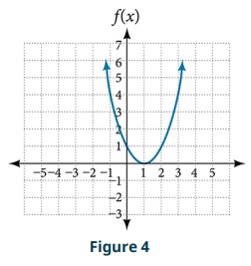
- Solve $f\left(x\right)=4$.

Solution:
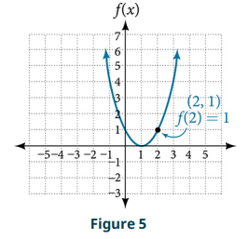
- To evaluate $f(2)$, locate the point on the curve where x = 2, then read the y-coordinate of that point. The point has coordinates (2, 1), so $f\left(2\right)=1$. See Figure 5.

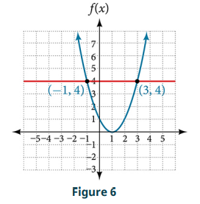
- To solve $f\left(x\right)=4$, we find the output value 4 on the vertical axis. Moving horizontally along the line $y=4$, we locate two points of the curve with output value 4: (-1, 4) and (3, 4). These points represent the two solutions to $f\left(x\right)=4:$ -1 or 3. This means $f\left(-1\right)=4$ and $f\left(3\right)=4$, or when the input is -1 or 3, the output is 4. See Figure 6.

- A function is one-to-one if each output value corresponds to only one input value.
Example: Is the area of a circle a function of its radius? If yes, is the function one-to-one?
Solution: A circle of radius r has a unique area measure given by $A=πr^{2}$, so for any input, r, there is only one output, A. The area function is a function of radius r.
If the function is one-to-one, the output value, the area, must correspond to a unique input value, the radius. Any area measure A is given by the formula $A=πr^{2}$. Because areas and radii are positive numbers, there is exactly one solution: $\sqrt{\frac{A}{π}}$. So, the area of a circle is a one-to-one function of the circle’s radius.

- A graph represents a function if any vertical line drawn on the graph intersects the graph at no more than one point.
Example: Which of the graphs in Figure 9 represent(s) a function $y=f(x)$?
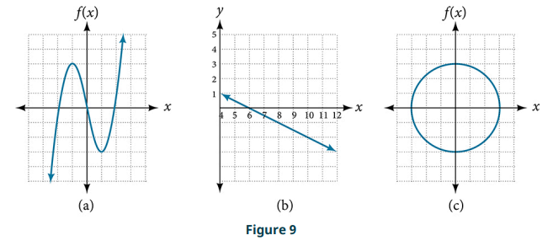

Solution: If any vertical line intersects a graph more than once, the relation represented by the graph is not a function. Notice that any vertical line would pass through only one point of the two graphs shown in parts (a) and (b) of Figure 9. From this we can conclude that these two graphs represent functions. The third graph does not represent a function because, at most x-values, a vertical line would intersect the graph at more than one point.

- The graph of a one-to-one function passes the horizontal line test.

- Example: Consider the functions shown in Figure 9a and Figure 9b. Are
either of the functions one-to-one?

Solution: The function in Figure 9a is not one-to-one. The horizontal line test shown in Figure 12 intersects the graph of the function at two points (and we can even find horizontal lines that intersect it at three points).

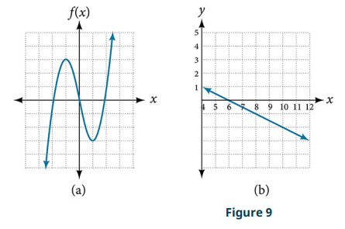
The function in Figure 9b is one-to-one. Any horizontal line will intersect a
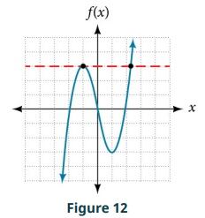
diagonal line at most once.

Functions and Function Notation Video
- Identifying Tables that Represent Functions: Example 1
- Evaluating Functions: Examples 2-3
- Solving Functions: Example 4
- Evaluating and Solving a Tabular Function: Example 5
- Reading Function Values from a Graph: Example 6
- Applying the Vertical Line Test: Example 7
- Applying the Horizontal Line Test: Example 8

Practice Exercises
Follow the directions for each exercise below:
- Determine whether the relation is a function: $\left\{\left(a, b\right), \left(c, d\right), \left(e, d\right)\right\}$.

- Determine whether the relation is a function: $\left\{\left(5, 2\right), \left(6, 1\right), \left(6, 2\right), (4, 8)\right\}$.

- Determine whether the relation is a function: $y^{2}+4=x$, for x the independent variable and y the dependent variable.

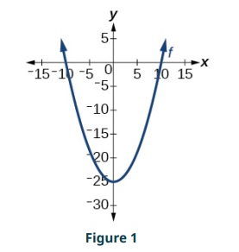
- Is the graph in Figure 1 a function?

- Evaluate $f\left(-3\right); f\left(2\right); f\left(-a\right); -f\left(a\right); f(a+h)$ for $f\left(x\right)=-2x^{2}+3x$.

- Evaluate $f\left(-3\right); f\left(2\right); f\left(-a\right); -f\left(a\right); f(a+h)$ for $f\left(x\right)=2|3x-1|$.

- Determine whether the function is one-to-one: $f\left(x\right)=-3x+5$.

- Determine whether the function is one-to-one: $f\left(x\right)=|x-3|$.

- Use the vertical line test to determine if the relation whose graph is provided is a
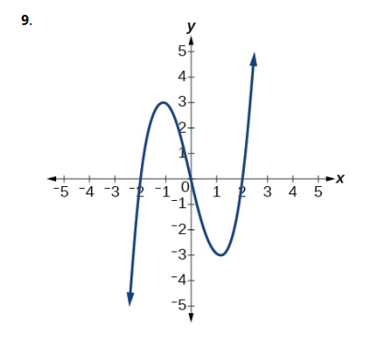
function

- Use the vertical line test to determine if the relation whose graph is provided is a function:
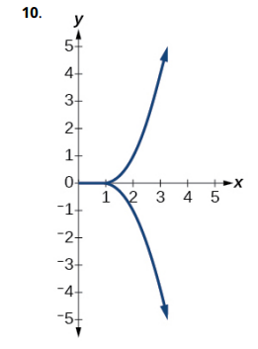

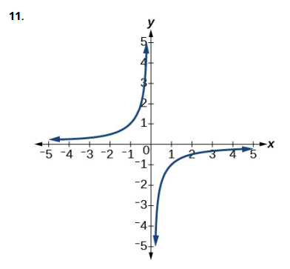
- Use the vertical line test to determine if the relation whose graph is provided is a function:
- Use Figure 2 to estimate the value $f(2)$:

- Use Figure 2 to estimate the value $f(-2)$:

- Use Figure 2 to solve for x if $f\left(x\right)=-2$:

- Use Figure 2 to solve for x if $f\left(x\right)=1$.
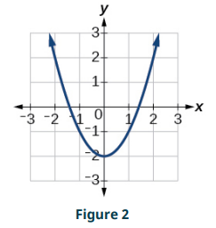

Answers:
- Function.

- Not a function.

- Not a function.

- Yes.

- $f\left(-3\right)=-27, f\left(2\right)=-2, f\left(-a\right)=-2a^{2}-3a, -f\left(a\right)=2a^{2}-3a,$

$$f\left(a+h\right)=-2a^{2}+3a-4ah+3h-2h^{2}$$

- $f\left(-3\right)=20, f\left(2\right)=10, f\left(-a\right)=2\left|-3a-1\right|, -f\left(a\right)=-2\left|3a-1\right|,$
$$f\left(a+h\right)=2|3a+3h-1|$$

- One-to-one.

- Not one-to-one.

- Function.

- Not a function.

- Function.

- 2

- 2

- $x=0$

- $x=-1.8 or x=1.8$

